“Digital Twin Solutions for Sea Ice” — joint workshop in Tallinn & online, 27–28 October 2025
Tallinn, Estonia — 27–28 October 2025 — TerraDT and NOCOS DT, two leading European initiatives in digital twin applications for the cryosphere, will host a joint interactive workshop in Tallinn (and online) to spotlight their latest advances in sea-ice modelling, impact assessment, and use of digital twins to support and improve climate science.
Sea ice plays a crucial role in the Earth’s climate system. Its seasonal cycles influence global temperatures, ocean circulation, and maritime safety. Rapid change in polar and sub-polar regions, including the Baltic Sea, demands innovative tools to support forecasting and adaptation.
Digital twins represent virtual replicas of complex systems powered by real-time data and artificial intelligence. As such, they offer unprecedented precision for monitoring and predicting these changes.
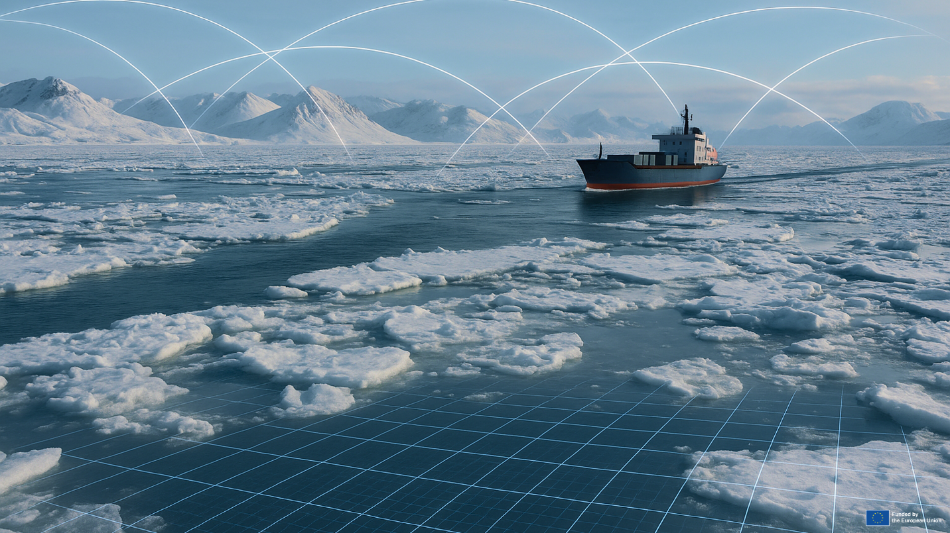

This 1.5 day workshop offers a unique opportunity for scientists, policy makers, industry professionals, media and the broader public to gain first-hand insights into how digital twin technologies are shaping our understanding of sea ice dynamics in the Arctic, Baltic, and more. During the event, experts from across Europe will present practical solutions that bridge science, policy, and societal needs, demonstrating how digital twins can inform better decisions on navigation safety, infrastructure, and environmental management.
More precisely the workshop will feature:
- Keynote sessions on cryosphere digital twin strategies, climate simulation, and Europe’s Destination Earth vision;
- Case studies on marine spatial planning, sea ice, ridged ice, landfast ice, marginal ice zones, and navigation risk modelling;
- Panel discussions on data integration, cross-domain collaboration and digital twin applications, the future of cryosphere digital services;
- Interactive working groups identifying user requirements for sea-ice impact models;
- Networking and poster sessions connecting researchers, innovators, and decision-makers.
Full agenda and registration details are available on the TerraDT website:
https://terradt.eu/events/digital-twin-solutions-sea-ice-joint-workshop
Journalists and media representatives are warmly invited to attend the workshop, either in person or online. Media participants will have the opportunity to:
- Interview leading experts from European projects working on sea-ice and digital twin technologies;
- Access data, visuals and highlights of sea-ice dynamics developed through the projects;
- Understand European innovation in climate technology and environmental data science.
Journalists and media outlets interested in writing an article or arranging interviews with speakers are invited to contact info@terradt.eu to coordinate and schedule interviews or coverage opportunities.
Venue: Swissôtel Tallinn, Tornimäe 3
Dates: 27 October (from 11:00 EET) – 28 October (until 14:00 EET)
Language: English

